|  |
| --- |
| > setwd("~/")  > getwd()  [1] "C:/Users/kghorpa/Documents"  > a<-read.csv("data.csv",header=T,sep=",")  Error in file(file, "rt") : cannot open the connection  In addition: Warning message:  In file(file, "rt") :  cannot open file 'data.csv': No such file or directory  > a<-read.csv("data.csv",header=T,sep=",")  Error in file(file, "rt") : cannot open the connection  In addition: Warning message:  In file(file, "rt") :  cannot open file 'data.csv': No such file or directory  > a<-read.csv("data.csv",header=T,sep=",")  Error in file(file, "rt") : cannot open the connection  In addition: Warning message:  In file(file, "rt") :  cannot open file 'data.csv': No such file or directory  > a<-read.csv("data.csv",header=T,sep=",")  Error in file(file, "rt") : cannot open the connection  In addition: Warning message:  In file(file, "rt") :  cannot open file 'data.csv': No such file or directory  > setwd("~/")  > getwd()  [1] "C:/Users/kghorpa/Documents"  > a<-read.csv("data.csv",header=T,sep=",")  Error in file(file, "rt") : cannot open the connection  In addition: Warning message:  In file(file, "rt") :  cannot open file 'data.csv': No such file or directory  > a<-read.csv("data.csv",header=T,sep=",")  > View(a)  > summary(a)  Store DayOfWeek Date  Min. : 1.0 Min. :1.000 2013-01-02: 1115  1st Qu.: 280.0 1st Qu.:2.000 2013-01-03: 1115  Median : 558.0 Median :4.000 2013-01-04: 1115  Mean : 558.4 Mean :3.998 2013-01-05: 1115  3rd Qu.: 838.0 3rd Qu.:6.000 2013-01-06: 1115  Max. :1115.0 Max. :7.000 2013-01-07: 1115  (Other) :1010519  Sales Customers Open  Min. : 0 Min. : 0.0 Min. :0.0000  1st Qu.: 3727 1st Qu.: 405.0 1st Qu.:1.0000  Median : 5744 Median : 609.0 Median :1.0000  Mean : 5774 Mean : 633.1 Mean :0.8301  3rd Qu.: 7856 3rd Qu.: 837.0 3rd Qu.:1.0000  Max. :41551 Max. :7388.0 Max. :1.0000    Promo StateHoliday SchoolHoliday  Min. :0.0000 0:986159 Min. :0.0000  1st Qu.:0.0000 a: 20260 1st Qu.:0.0000  Median :0.0000 b: 6690 Median :0.0000  Mean :0.3815 c: 4100 Mean :0.1786  3rd Qu.:1.0000 3rd Qu.:0.0000  Max. :1.0000 Max. :1.0000 |
|  |
| |  | | --- | | > | |

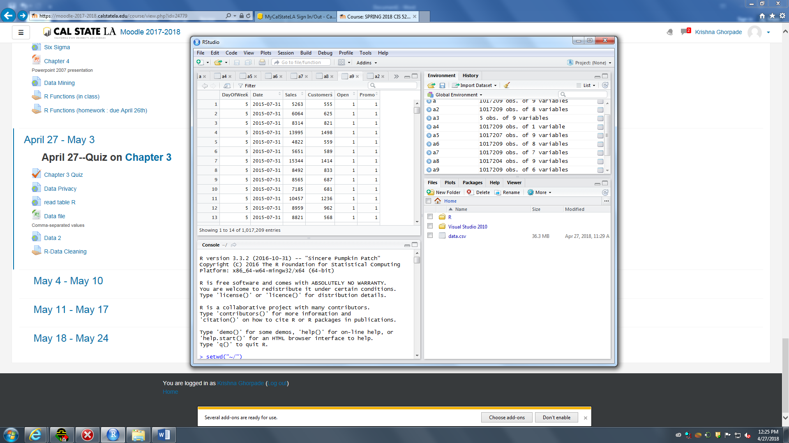

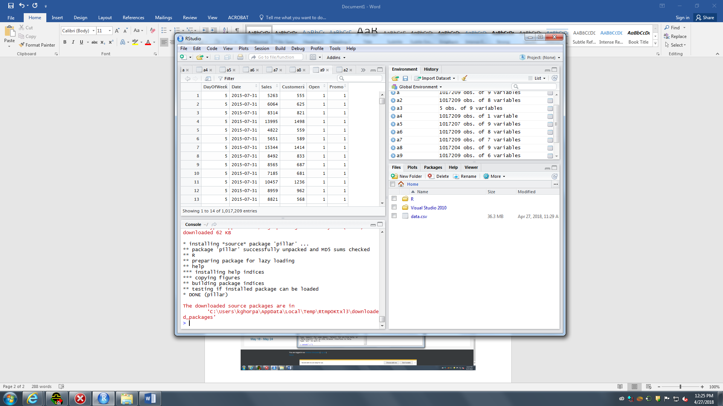

R version 3.3.2 (2016-10-31) -- "Sincere Pumpkin Patch"

Copyright (C) 2016 The R Foundation for Statistical Computing

Platform: x86_64-w64-mingw32/x64 (64-bit)

R is free software and comes with ABSOLUTELY NO WARRANTY.

You are welcome to redistribute it under certain conditions.

Type 'license()' or 'licence()' for distribution details.

R is a collaborative project with many contributors.

Type 'contributors()' for more information and

'citation()' on how to cite R or R packages in publications.

Type 'demo()' for some demos, 'help()' for on-line help, or

'help.start()' for an HTML browser interface to help.

Type 'q()' to quit R.

> setwd("~/")

> getwd()

[1] "C:/Users/kghorpa/Documents"

> a<-read.csv("data.csv",header=T,sep=",")

Error in file(file, "rt") : cannot open the connection

In addition: Warning message:

In file(file, "rt") :

cannot open file 'data.csv': No such file or directory

> a<-read.csv("data.csv",header=T,sep=",")

Error in file(file, "rt") : cannot open the connection

In addition: Warning message:

In file(file, "rt") :

cannot open file 'data.csv': No such file or directory

> a<-read.csv("data.csv",header=T,sep=",")

Error in file(file, "rt") : cannot open the connection

In addition: Warning message:

In file(file, "rt") :

cannot open file 'data.csv': No such file or directory

> a<-read.csv("data.csv",header=T,sep=",")

Error in file(file, "rt") : cannot open the connection

In addition: Warning message:

In file(file, "rt") :

cannot open file 'data.csv': No such file or directory

> setwd("~/")

> getwd()

[1] "C:/Users/kghorpa/Documents"

> a<-read.csv("data.csv",header=T,sep=",")

Error in file(file, "rt") : cannot open the connection

In addition: Warning message:

In file(file, "rt") :

cannot open file 'data.csv': No such file or directory

> a<-read.csv("data.csv",header=T,sep=",")

> View(a)

> summary(a)

Store DayOfWeek Date

Min. : 1.0 Min. :1.000 2013-01-02: 1115

1st Qu.: 280.0 1st Qu.:2.000 2013-01-03: 1115

Median : 558.0 Median :4.000 2013-01-04: 1115

Mean : 558.4 Mean :3.998 2013-01-05: 1115

3rd Qu.: 838.0 3rd Qu.:6.000 2013-01-06: 1115

Max. :1115.0 Max. :7.000 2013-01-07: 1115

(Other) :1010519

Sales Customers Open

Min. : 0 Min. : 0.0 Min. :0.0000

1st Qu.: 3727 1st Qu.: 405.0 1st Qu.:1.0000

Median : 5744 Median : 609.0 Median :1.0000

Mean : 5774 Mean : 633.1 Mean :0.8301

3rd Qu.: 7856 3rd Qu.: 837.0 3rd Qu.:1.0000

Max. :41551 Max. :7388.0 Max. :1.0000

Promo StateHoliday SchoolHoliday

Min. :0.0000 0:986159 Min. :0.0000

1st Qu.:0.0000 a: 20260 1st Qu.:0.0000

Median :0.0000 b: 6690 Median :0.0000

Mean :0.3815 c: 4100 Mean :0.1786

3rd Qu.:1.0000 3rd Qu.:0.0000

Max. :1.0000 Max. :1.0000

> a2<-a[,2:ncol(a)]

> View(a2)

> View(a2)

> View(a)

> a[1:5,]

Store DayOfWeek Date Sales Customers Open Promo

1 1 5 2015-07-31 5263 555 1 1

2 2 5 2015-07-31 6064 625 1 1

3 3 5 2015-07-31 8314 821 1 1

4 4 5 2015-07-31 13995 1498 1 1

5 5 5 2015-07-31 4822 559 1 1

StateHoliday SchoolHoliday

1 0 1

2 0 1

3 0 1

4 0 1

5 0 1

> a3<-a[1:5,]

> view(a3)

Error: could not find function "view"

> View(a3)

> a[1:,]

Error: unexpected ',' in "a[1:,"

> a[1:n,]

Error in `[.data.frame`(a, 1:n, ) : object 'n' not found

> a4<-a[,4:]

Error: unexpected ']' in "a4<-a[,4:]"

> a4<-a[4]

> View(a4)

> a5<-a[-(1:2),]

> View(a5)

> a6<-a[-6]

> View(a6)

> a7<-a[,-6],[,-7]

Error: unexpected ',' in "a7<-a[,-6],"

> a7<-a[,-6,-7]

> View(a7)

> a7<-a[,-6:,-7]

Error: unexpected ',' in "a7<-a[,-6:,"

> a7<-a[,-6:-7]

> View(a7)

> a8<-a[-(1:5),]

> View(a8)

> keep_set<-c(2:(ncol(a)-2))

> a9<-a[,keep_set]

> View(a9)

> install.packages("tidyr")

Installing package into ‘C:/Users/kghorpa/Documents/R/win-library/3.3’

(as ‘lib’ is unspecified)

also installing the dependencies ‘bindr’, ‘utf8’, ‘assertthat’, ‘bindrcpp’, ‘pkgconfig’, ‘R6’, ‘BH’, ‘plogr’, ‘cli’, ‘crayon’, ‘pillar’, ‘dplyr’, ‘glue’, ‘magrittr’, ‘purrr’, ‘Rcpp’, ‘rlang’, ‘stringi’, ‘tibble’, ‘tidyselect’

There is a binary version available but the source

version is later:

binary source needs_compilation

pillar 1.2.1 1.2.2 FALSE

trying URL 'https://cran.rstudio.com/bin/windows/contrib/3.3/bindr_0.1.1.zip'

Content type 'application/zip' length 15013 bytes (14 KB)

downloaded 14 KB

trying URL 'https://cran.rstudio.com/bin/windows/contrib/3.3/utf8_1.1.3.zip'

Content type 'application/zip' length 193991 bytes (189 KB)

downloaded 189 KB

trying URL 'https://cran.rstudio.com/bin/windows/contrib/3.3/assertthat_0.2.0.zip'

Content type 'application/zip' length 43500 bytes (42 KB)

downloaded 42 KB

trying URL 'https://cran.rstudio.com/bin/windows/contrib/3.3/bindrcpp_0.2.2.zip'

Content type 'application/zip' length 620071 bytes (605 KB)

downloaded 605 KB

trying URL 'https://cran.rstudio.com/bin/windows/contrib/3.3/pkgconfig_2.0.1.zip'

Content type 'application/zip' length 19759 bytes (19 KB)

downloaded 19 KB

trying URL 'https://cran.rstudio.com/bin/windows/contrib/3.3/R6_2.2.2.zip'

Content type 'application/zip' length 316526 bytes (309 KB)

downloaded 309 KB

trying URL 'https://cran.rstudio.com/bin/windows/contrib/3.3/BH_1.66.0-1.zip'

Content type 'application/zip' length 17879774 bytes (17.1 MB)

downloaded 17.1 MB

trying URL 'https://cran.rstudio.com/bin/windows/contrib/3.3/plogr_0.2.0.zip'

Content type 'application/zip' length 18461 bytes (18 KB)

downloaded 18 KB

trying URL 'https://cran.rstudio.com/bin/windows/contrib/3.3/cli_1.0.0.zip'

Content type 'application/zip' length 304554 bytes (297 KB)

downloaded 297 KB

trying URL 'https://cran.rstudio.com/bin/windows/contrib/3.3/crayon_1.3.4.zip'

Content type 'application/zip' length 708997 bytes (692 KB)

downloaded 692 KB

trying URL 'https://cran.rstudio.com/bin/windows/contrib/3.3/dplyr_0.7.4.zip'

Content type 'application/zip' length 2897358 bytes (2.8 MB)

downloaded 2.8 MB

trying URL 'https://cran.rstudio.com/bin/windows/contrib/3.3/glue_1.2.0.zip'

Content type 'application/zip' length 72364 bytes (70 KB)

downloaded 70 KB

trying URL 'https://cran.rstudio.com/bin/windows/contrib/3.3/magrittr_1.5.zip'

Content type 'application/zip' length 149761 bytes (146 KB)

downloaded 146 KB

trying URL 'https://cran.rstudio.com/bin/windows/contrib/3.3/purrr_0.2.4.zip'

Content type 'application/zip' length 244026 bytes (238 KB)

downloaded 238 KB

trying URL 'https://cran.rstudio.com/bin/windows/contrib/3.3/Rcpp_0.12.16.zip'

Content type 'application/zip' length 4358189 bytes (4.2 MB)

downloaded 4.2 MB

trying URL 'https://cran.rstudio.com/bin/windows/contrib/3.3/rlang_0.2.0.zip'

Content type 'application/zip' length 754726 bytes (737 KB)

downloaded 737 KB

trying URL 'https://cran.rstudio.com/bin/windows/contrib/3.3/stringi_1.1.7.zip'

Content type 'application/zip' length 14289043 bytes (13.6 MB)

downloaded 13.6 MB

trying URL 'https://cran.rstudio.com/bin/windows/contrib/3.3/tibble_1.4.2.zip'

Content type 'application/zip' length 172305 bytes (168 KB)

downloaded 168 KB

trying URL 'https://cran.rstudio.com/bin/windows/contrib/3.3/tidyselect_0.2.4.zip'

Content type 'application/zip' length 612053 bytes (597 KB)

downloaded 597 KB

trying URL 'https://cran.rstudio.com/bin/windows/contrib/3.3/tidyr_0.8.0.zip'

Content type 'application/zip' length 899429 bytes (878 KB)

downloaded 878 KB

package ‘bindr’ successfully unpacked and MD5 sums checked

package ‘utf8’ successfully unpacked and MD5 sums checked

package ‘assertthat’ successfully unpacked and MD5 sums checked

package ‘bindrcpp’ successfully unpacked and MD5 sums checked

package ‘pkgconfig’ successfully unpacked and MD5 sums checked

package ‘R6’ successfully unpacked and MD5 sums checked

package ‘BH’ successfully unpacked and MD5 sums checked

package ‘plogr’ successfully unpacked and MD5 sums checked

package ‘cli’ successfully unpacked and MD5 sums checked

package ‘crayon’ successfully unpacked and MD5 sums checked

package ‘dplyr’ successfully unpacked and MD5 sums checked

package ‘glue’ successfully unpacked and MD5 sums checked

package ‘magrittr’ successfully unpacked and MD5 sums checked

package ‘purrr’ successfully unpacked and MD5 sums checked

package ‘Rcpp’ successfully unpacked and MD5 sums checked

package ‘rlang’ successfully unpacked and MD5 sums checked

package ‘stringi’ successfully unpacked and MD5 sums checked

package ‘tibble’ successfully unpacked and MD5 sums checked

package ‘tidyselect’ successfully unpacked and MD5 sums checked

package ‘tidyr’ successfully unpacked and MD5 sums checked

The downloaded binary packages are in

C:\Users\kghorpa\AppData\Local\Temp\RtmpOKtxl3\downloaded_packages

installing the source package ‘pillar’

trying URL 'https://cran.rstudio.com/src/contrib/pillar_1.2.2.tar.gz'

Content type 'application/x-gzip' length 64185 bytes (62 KB)

downloaded 62 KB

* installing *source* package 'pillar' ...

** package 'pillar' successfully unpacked and MD5 sums checked

** R

** preparing package for lazy loading

** help

*** installing help indices

*** copying figures

** building package indices

** testing if installed package can be loaded

* DONE (pillar)

The downloaded source packages are in

‘C:\Users\kghorpa\AppData\Local\Temp\RtmpOKtxl3\downloaded_packages’

> library(tidyr)

Warning message:

package ‘tidyr’ was built under R version 3.3.3

> a10<-separate(a.Date,c("year","month","day"),sep="-")

Error in separate(a.Date, c("year", "month", "day"), sep = "-") :

object 'a.Date' not found

> a10<-separate(a,Date,c("year","month","day"),sep="-")

> View(a10)

> a10<-separate(a,Date,c("year","Month","Day"),sep="-")

> View(a10)

> a11<-unite(a,Date,c("year","Month","Day"),sep="-")

Error: Unknown column `year`

> a10<-separate(a,Date,c("Year","Month","Day"),sep="-")

> View(a10)

> a11<-unite(a,Date,c("Year","Month","Day"),sep="-")

Error: Unknown column `Year`

> a10<-separate(a,Date,c("Year","Month","Day"),sep="-",remove=TRUE)

> View(a10)

> a10<-unite(a,Date,c("Year","Month","Day"),sep="-",remove=TRUE)

Error: Unknown column `Year`

> a10<-unite(a,Date,c("Year","Month","Day"),sep="-",remove=TRUE)

Error: Unknown column `Year`

> a11<-unite(a10,Date,c("Year","Month","Day"),sep="-",remove=TRUE)

> View(a11)